Bapuji Educational Association ®
D. R. M. Science College, Davangere

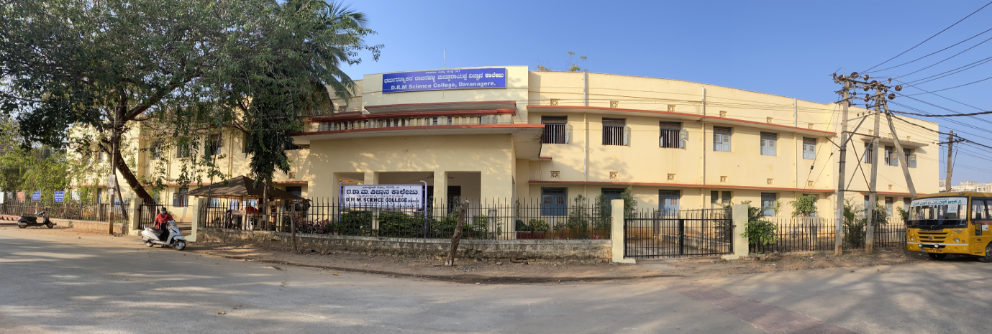

CALENDER OF EVENTS FOR THE ACADEMIC YEAR 2022-23
Odd Semester

SL. No. | Events | Date
 | Odd Semester
1 | College re-opening for I Semester | 22.08.2022
2 | Ganesha Chathurti - General Holiday | 31.08.2023
3 | Gandhiji & Lal Bahudur Jayanthi- General Holiday | 02.10.2023
4 | Ayudha Pooja - General Holiday | 04.10.2023
5 | Vijaya Dhashami - General Holiday | 05.10.2023
6 | College re-opening for III & V Semesters | 19.10.2022
7 | Naraka Chaturdashi - General Holiday | 24.10.2022
8 | Deepavali- General Holiday | 26.10.2022
9 | Koti Kantha Gayana Programme | 28.10.2022
10 | Kannada Rajyotsava - General Holiday | 01.11.2022
11 | IQAC Meeting -01 | 02.11.2022
12 | Kanakadasa jayanthi – General Holiday | 11.11.2022
13 | Orientation programme for I B.Sc. students and  Parents meet | 14.11.2022
14 | Skill Plus Orientation Programme | 18.11.2022
15 | I Internal Assessment Test | 23.24.25.26 Nov 2022
16 | CO- CURRICULAR AND EXTRA CURRICULAR ACTIVITIES INAUGURATION. | 28.11.2022
17 | Awareness On Blood Donation And Aids Day | 01.12.2022
18 | AISHE Submission | 19.12.2022
19 | SUBMISSION OF AQAR 2021-22 | 26.12.2022
20 | II Internal Assessment Test | 26.27.28.29 Dec 2022
21 | IQAC Meeting -02 | 07.01.2023
22 | Commencement of Practical Examination for Odd Semester | 20.01.2023 to 30.01.2023
23 | Republic Day | 26.01.2023
24 | Commencement of Semester end Examination | 06.02.2023
25 | Even Semester
26 | College re-opening for II, IV&VI Semesters | 02.03.2023
27 | IQAC Meeting -03 | 05.03.2023
28 | National Science Day | 06.03.2023
29 | International Women’s Day | 11.03.2023
30 | Anti-sexual Harassment cell programme | 18.03.2023
31 | Ugadhi Festival- General Holiday | 22.03.2023
32 | Human Rights Committee Programme | 25.03.2023
33 | Youth Red Cross Programme | 01.04.2023
34 | Mahavira Jayanthi – General Holiday | 04.04.2023
35 | Good Friday | 07.04.2023
36 | Science Forum Programme | 08.04.2023
37 | IQAC Meeting - 04 | 09.05.2023
38 | Ambedkar Jayanthi | 14.04.2023
39 | Anti-sexual Harassment cell programme | 15.04.2023
40 | I Internal Assessment Test | 17,18,19,20 April 2023
41 | Human Rights Committee Programme | 21.04.2023
42 | Ramzan Festival - General Holiday | 22.04.2023
43 | Cultural Competition | 23.04.2023
44 | Youth Red Cross Programme | 29.04.2023
45 | Special Lecture Programmes from all departments | 24.04.2023 to 04.05.2023
46 | May Day | 01.05.2023
47 | Science Forum Programme | 06.05.2023
48 | Cultural Competition | 08.05.2023
49 | Students Seminars from all departments | 10.05.2023 to 16.05.2023
50 | II Internal Assessment Test | 22, 23, 24, 25 May 2023
51 | Ethnic Day | 31.05.2023
52 | Annual Sports Day | 03.06.2023
53 | Valedictory functions of all committees | 10.06.2023
54 | Commencement of Practical Examination for Even Semester | 19.06.2023
55 | Bakrid Festival - General Holiday | 28.06.2023
56 | Closing of Academic year 2022-23 | 01.07.2023
57 | Commencement of Semester end Examination | 03.07.2023
58 | Last working Day | 14.08.2023

Note: All the departments have to conduct at least one National level Seminar/Workshop in the academic year 2022-23

IQAC Coordinator Principal

Grievance and Redressal Cell
2021-22

Grievance and Redressal Cell
2022-23

Academic and Administrative Audit Report
Department Of Computer-Science

Audit Details

